**Survey results from Day 1 – Event 6 in Sasd, Hungary**

During the first day of the event in Sasd, Hungary (Wednesday, September 18th 2024), the Municipality of Sasd and Sásd és Térsége Nonprofit Kft. (the hosts) held a live mentimeter survey with the participants. This was done in order to encourage discussion about the effects of the COVID-19 pandemic on the mental well-being of the community (especially concerning persons with disabilities, youth and the elderly). Through discussion it was hoped that the partners would detail the barriers they face in their communities regarding the “return to normal.”

The following document presents the questions that were asked and the feedback that was collected from the participants (cca. 40 persons in the audience). The questions that presented included:

**1) Which groups were most impacted by the COVID-19 pandemic?**

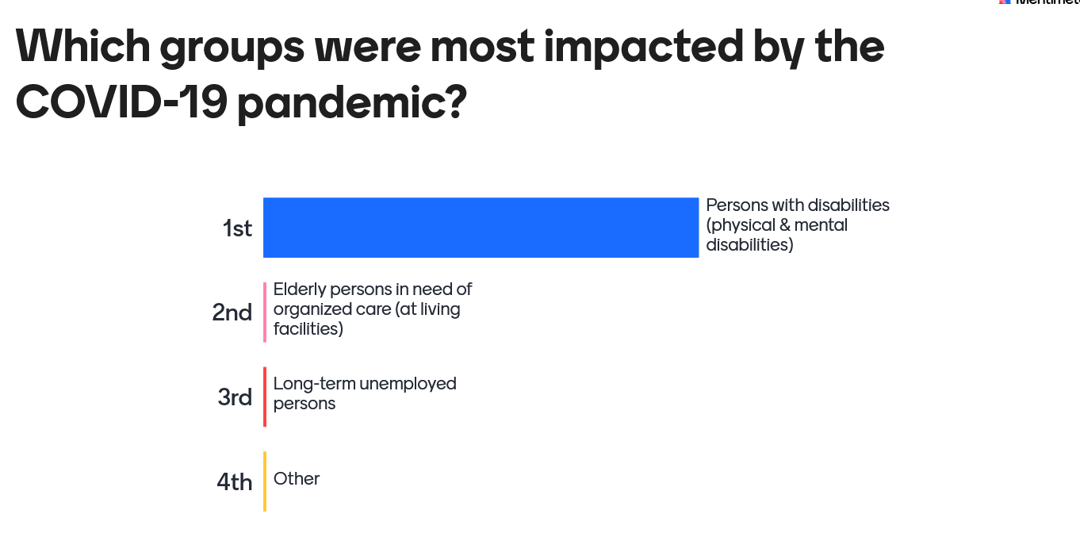

Based on the discussion and feedback, the participants considered that persons with disabilities (and their families) were the most impacted by the pandemic. These persons and their families needed extensive support prior to the pandemic in multiple fields (education, healthcare, social care, etc.) and after the pandemic was declared they were considered to be the most isolated and in need of help (which often did not come readily). It was agreed that pandemic showed rural communities that more inclusive actions need to take place; allowing for persons with disabilities to engage in the community and be active members in the community.

Apart from persons with disabilities. the pandemic was also considered to have had a negative impact on elderly persons in the community. The participants present work regularly with these citizens and it was mentioned that during the pandemic these persons felt lonely, abandoned and without help. Participants from Sopotniki mentioned that their transportation services which is free-of-charge had helped greatly as these citizens could connect with loved ones, get to doctor appointments, shop for food, etc. Participants mentioned that such services would be of benefit to elderly persons and others in need in their communities.

**2)** **In terms of gender, who was the most impacted?**

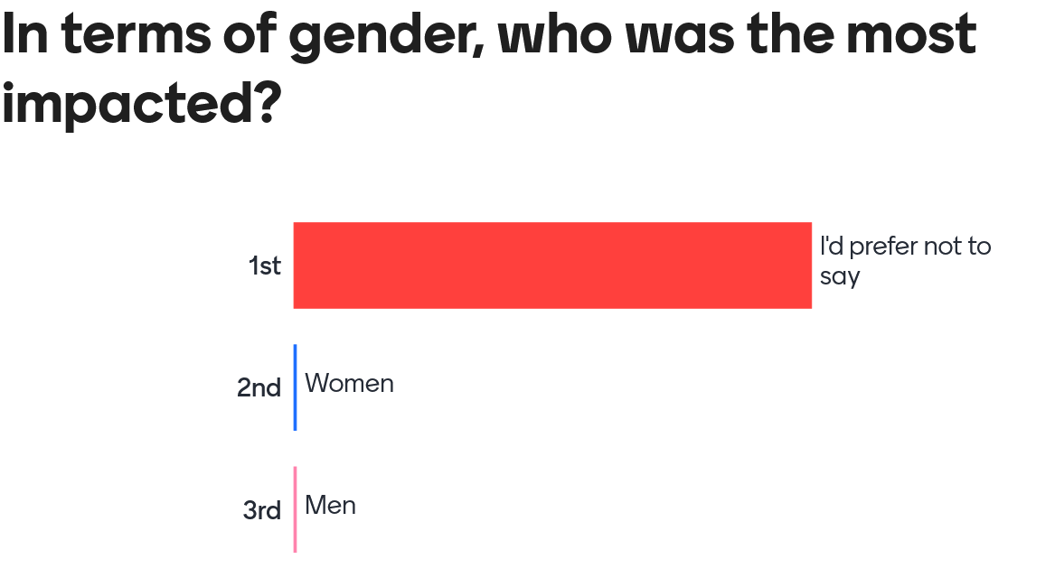

This question proved to be the most sensitive, and most of the participants refrained from saying whether women or men were most impacted. During the discussion, the participants talked about how the pandemic impacted different people. Concerning women, it was mentioned that the mothers (especially those who are single-mothers and those with new born-children) had most likely faced huge challenges. They couldn’t access healthcare, children had to stay home and be taken care of, and some were expected to work while also take care of children’s education needs (zoom classes). Men also faced specific challenges. One sub-section that was mentioned was young men and women, who lived on their own. It was considered that pandemic had a negative impact on their mental health as the pandemic reinforced young people to use their mobile phones as a life line to the community.

**3) During the pandemic, what activities were the most effective in helping elderly persons in need of care?**

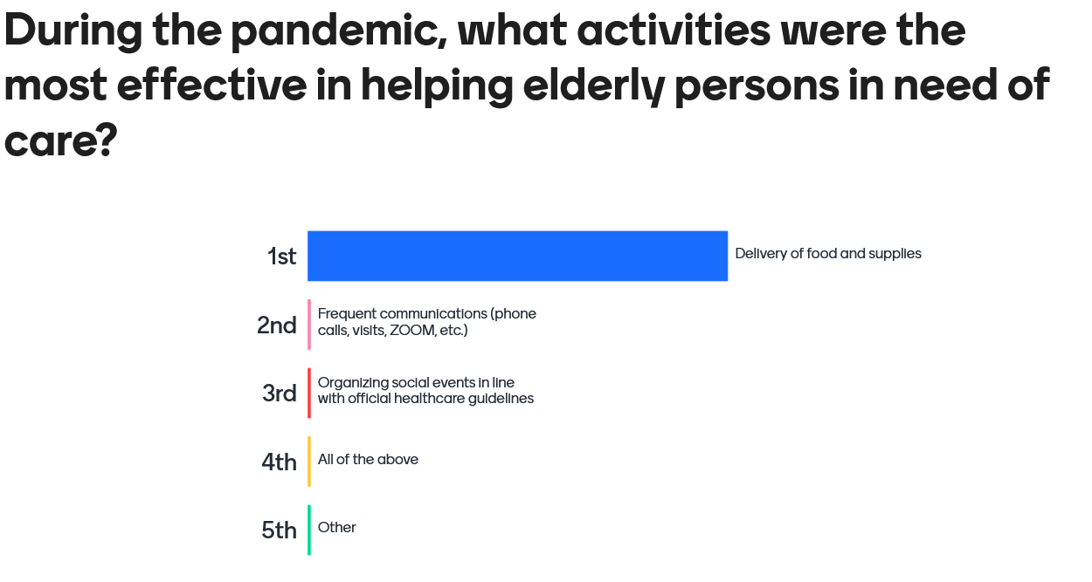

In answering this question, participants considered the safety risks during the pandemic as well as the mental health risks. The main focus was the start of the pandemic and in considering this scenario, the majority of the participants considered limited physical contact with short conversations to be an activity that was safe and good for one’s mental well-being. Delivering food supplies brought people briefly together and also ensured that these persons received support to live their daily lives. The other options were also discussed. ZOOM meetings/teleconferencing was considered ineffective with the elderly, as it often presented new challenges (e.g. many elderly persons had to learn how to use ZOOM). Social events were considered a better option than ZOOM, but at the same time such events meant that there was a good chance of spreading the virus further.

**4) What activities during the pandemic were the most effective in helping persons with disabilities?**

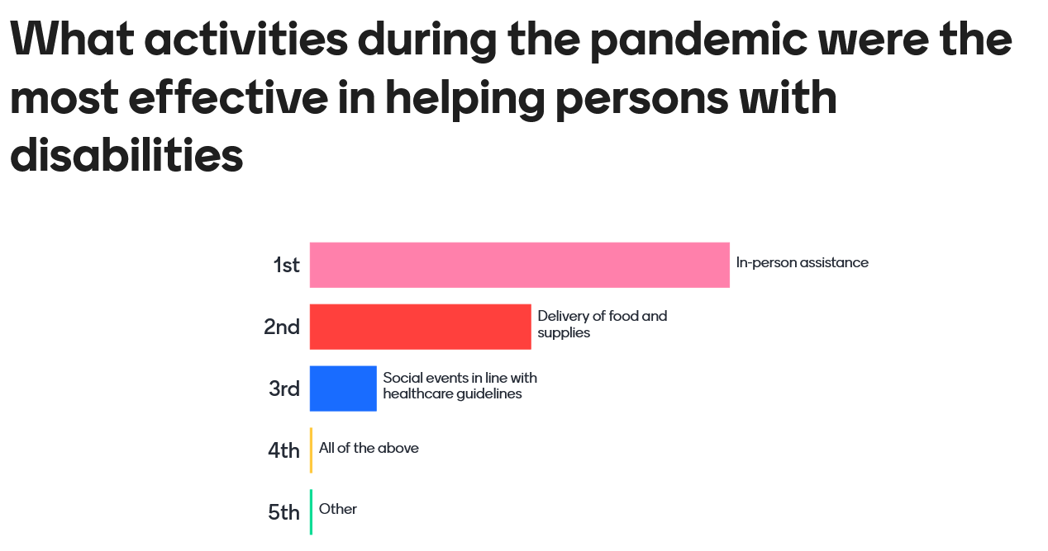

For persons with disabilities, it was considered that in-person help was absolutely necessary. Despite their being health and safety risks posed by the pandemic, these persons and their families still required in-house support in order to be included in the community. Without this, families could not function during the pandemic. In addition to these activities, the delivery of food and supplies was considered a good measure, and social events where persons with disabilities could leave their homes were also considered to be positive measures by the participants.

**5) Since the end of the pandemic, what’s the status of support and services for the most vulnerable in the community?**

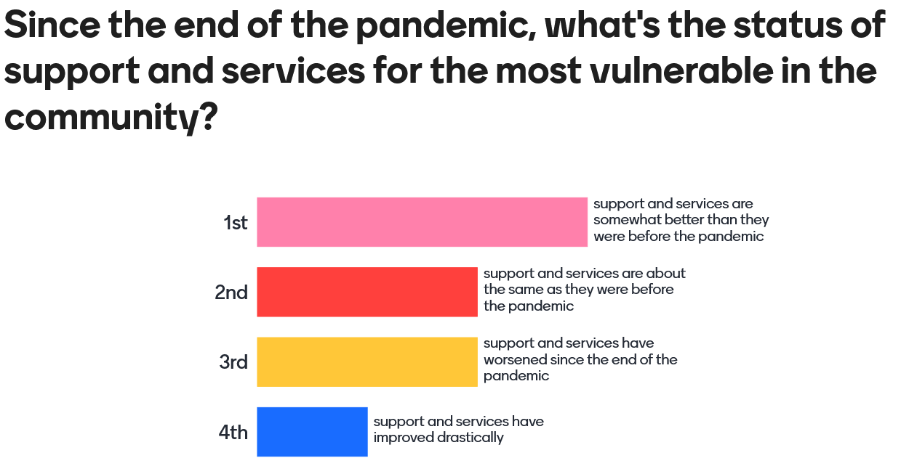

In response to this question, there were a variety of answers. For the most part, participants considered that citizens believe that support and services have somewhat improved. The pandemic resulted in new innovations and approaches to addressing the needs of the most vulnerable in the community, and many of these approaches are still in use. The main example is the appearance of free-of-charge transport services for the elderly and persons with disabilities in rural communities. The other participants mentioned that services and support have either remained the same or even worsened. Many participants mentioned that after the pandemic it seemed that the world did a massive reset. In other words, some participants felt that the general atmosphere in the community is similar to that in late 2019, meaning that the level of services and support for the most vulnerable have gone backward to a previous standard.

The survey overall was considered a good way for the participants to share their thoughts and feelings about the impact of the pandemic on the most vulnerable in the community. The idea of establishing free-of-charge transport services for those most in need was considered by all as an effective programme for social inclusion in the community. It was also concluded that the pandemic indeed impacted citizens differently. However, the participants emphasized that future projects ought to consider the needs of persons with disabilities and the elderly population the most.